AUTOML ENVIRONMENT SETUP AND INSTALLATION GUIDE

DOWNLOAD IDLE PYTHON:
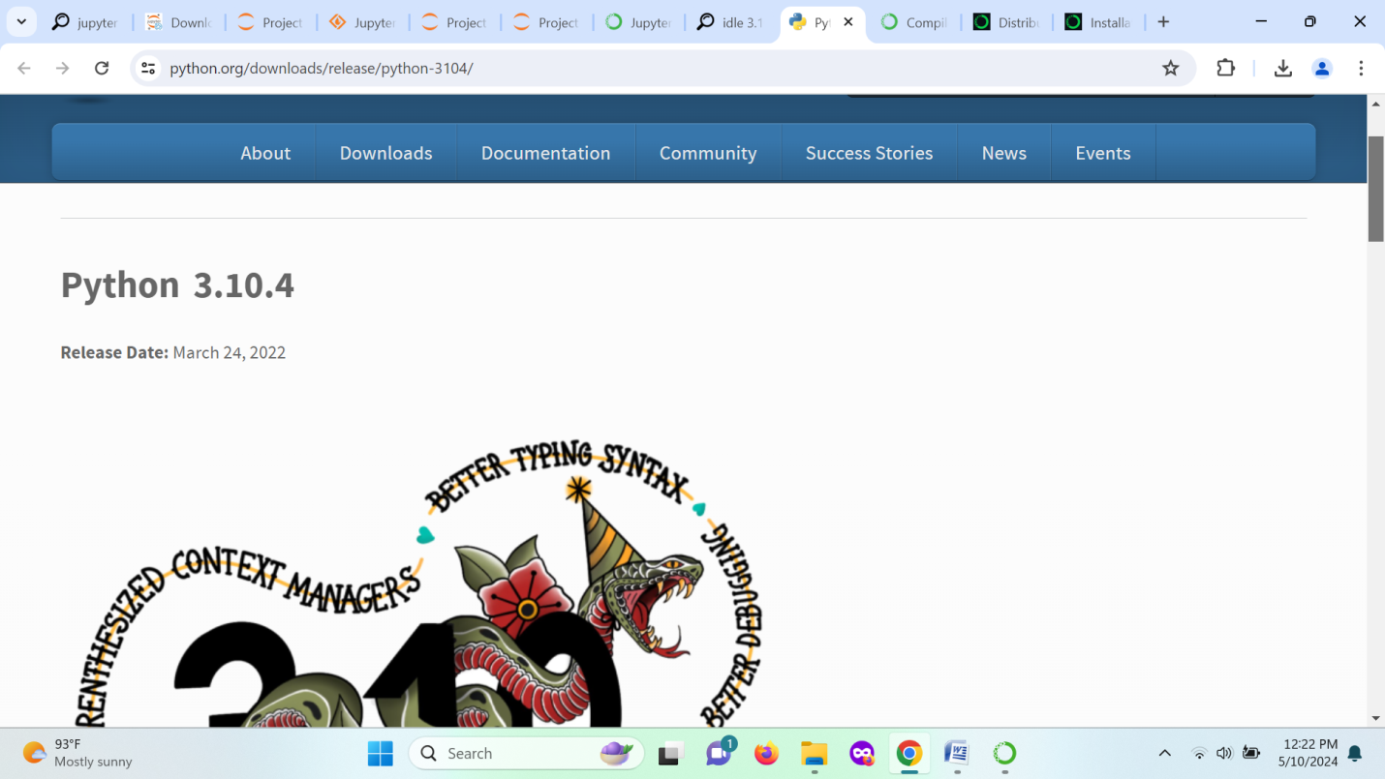
Download the python idle 3.10.4 and link is given below.
https://www.python.org/downloads/release/python-3104/

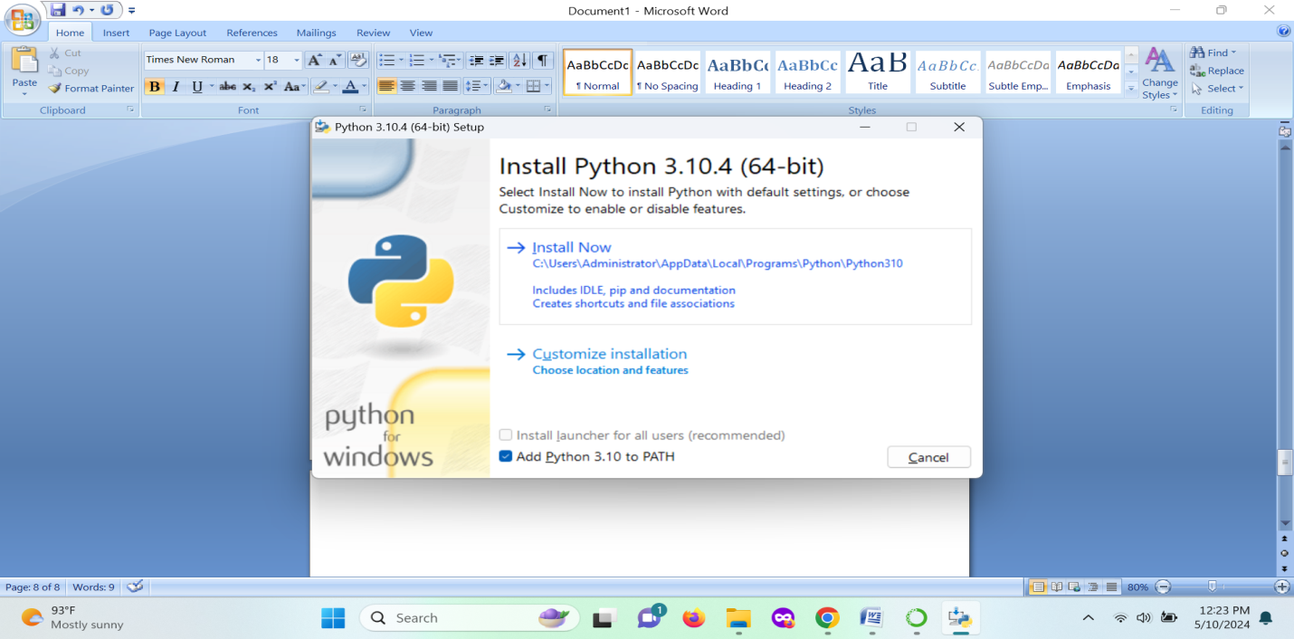
Click install and processed the initialization.

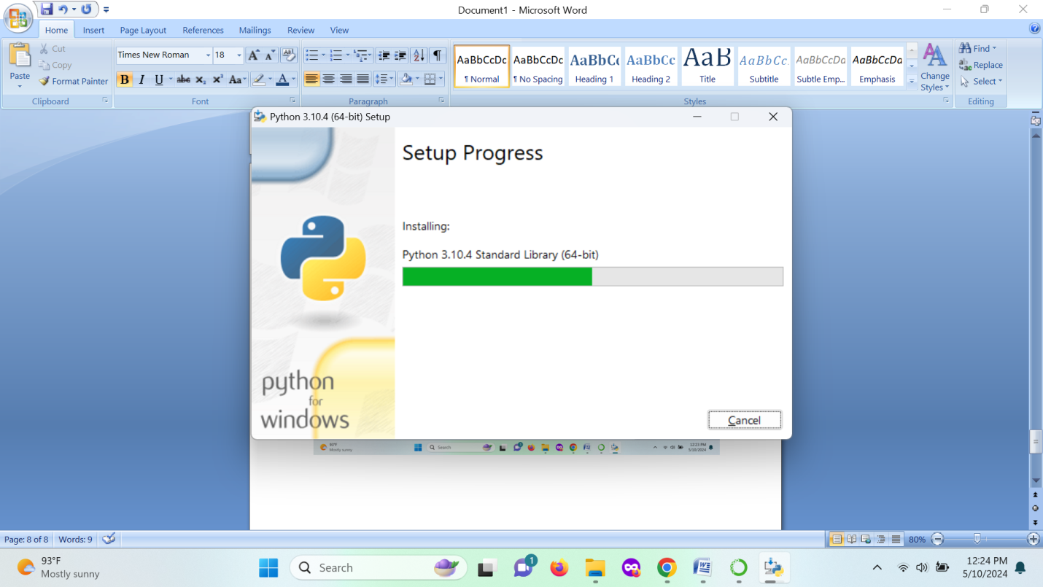
Setup is running in process.

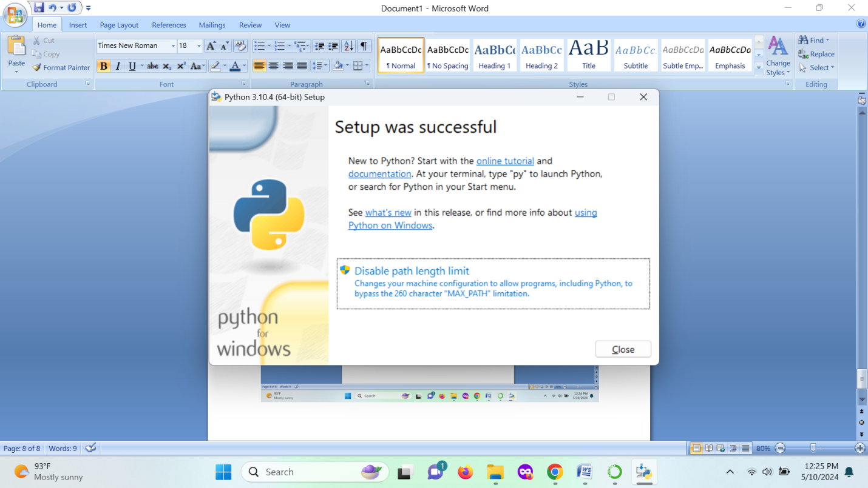
Setup completed successfully.

PYCARET INSTALLATION:
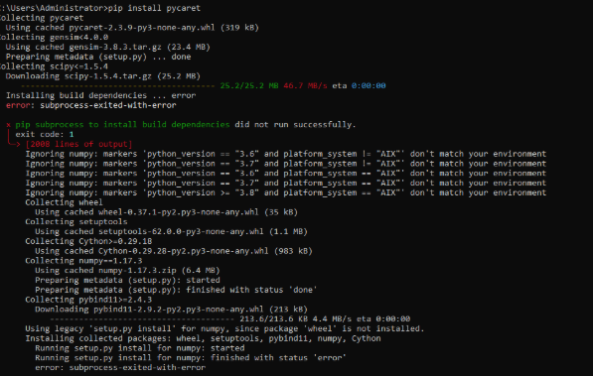

INSTALLATION OF STEAMLIT:
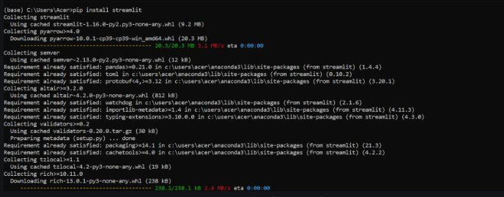

INSTALLATION TENSORFLOW:
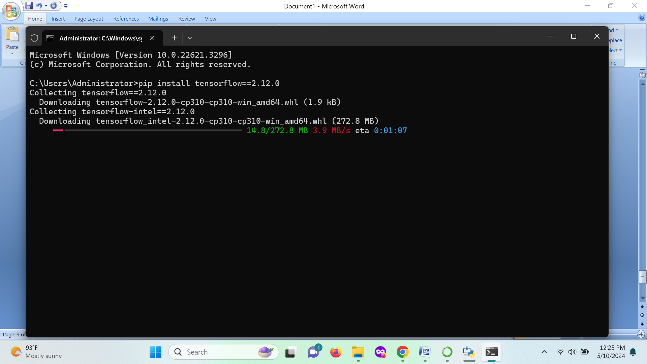
Tensor flow installed using the above commend.

PANDAS:
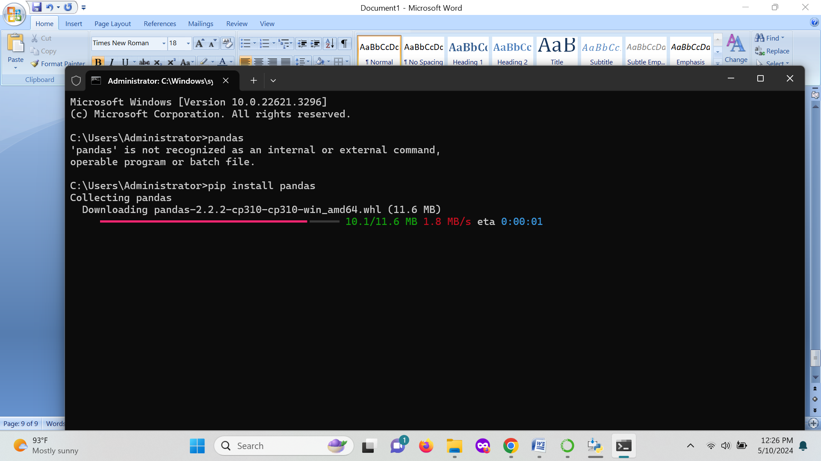
Pandas can be installed using the command pip install pandas 2.2.2.

KERAS:
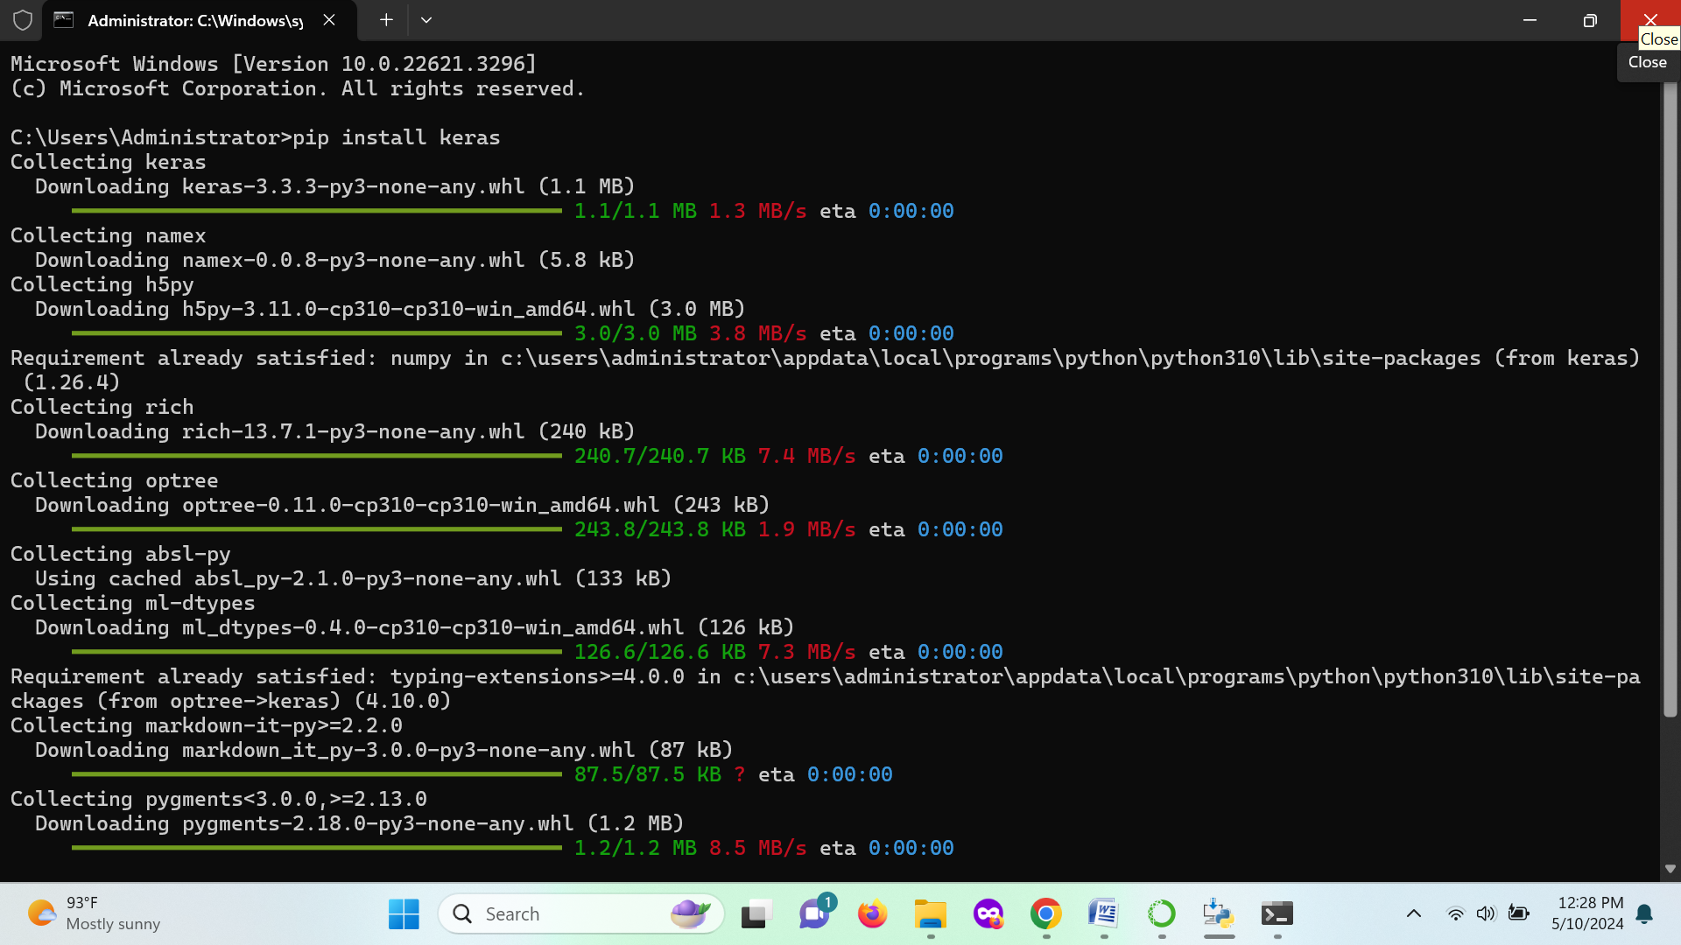Keras can be installed using pip install keras 3.3.3.
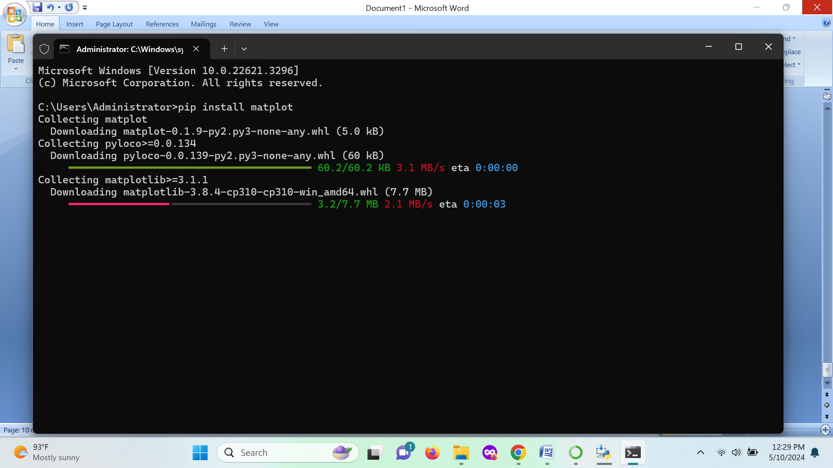
Pip install matplot and the matplot of 0.1.9 version is installed.

SCIKIT-LEARN:
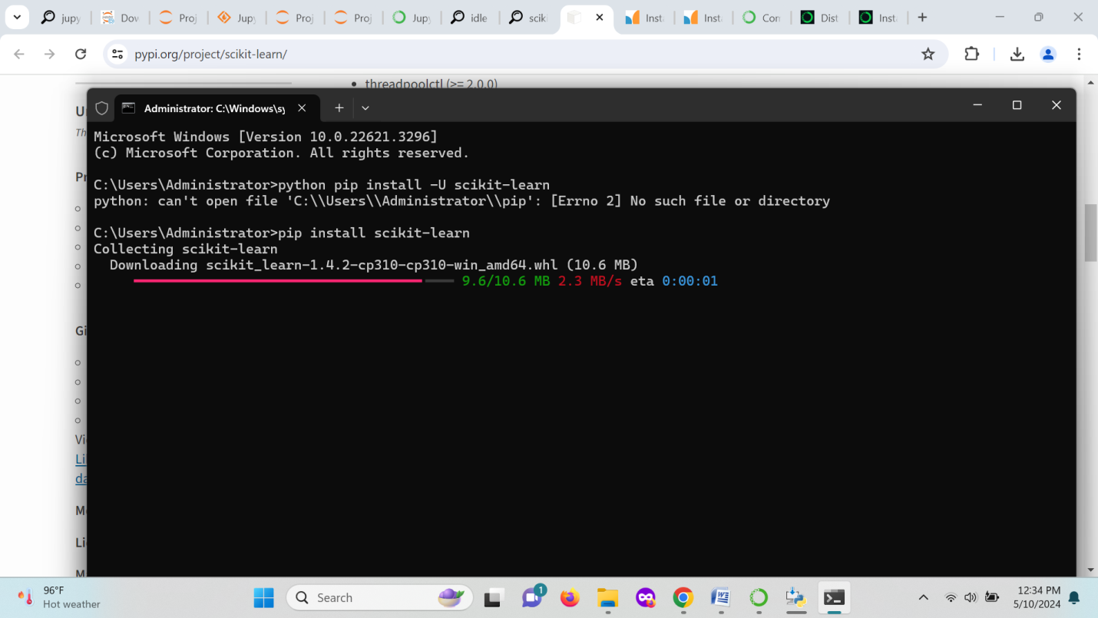pip install scikit-learn is the commend used to this package with the version of 1.4.2.

